Chapter 5, Problem 63.

Determine the gain v_{o}/v_{i} of the circuit in Fig. 5.90.

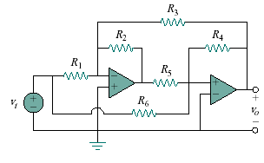
–
+
Figure 5.90
For Prob. 5.63.

